Student Learning Assessment Plan Summary

Operational Unit: Engineering Graphics Technology
Mission: provide students with excellent academic experience, in order to prepare them for the workforce by teaching the skills required in their field of discipline. We do this by developing abilities in communication, leadership, critical thinking, problem solving and teamwork.

OU broad learning goals:
- Student success
- Industry outreach
- Strengthen program offerings
- Maintain adjunct faculty related to industry

Step 1: Provide a narrative overview of the assessment process.
Starting with this process, CAD101 and CAD120; or maybe CAD224 will be the courses to pilot.
All instructors teaching these courses, and advisory members will be evaluating and assessing the results. To be able to start the assessment process, we will find out what students services at RRCC are available list them and present them to students (post in lab and use D2L course). Do a walk around campus to find out where everything is located. The assessment will consist on observations (responding to a created questionnaire to respond for each class), collect and analyze data to make improvement/adjustments to next semester’s class.
Associated with this process we will check for webinars, conferences or professional training related to software program skills for the instructor.

Step 2: Specific Student Learning Outcomes
The specific Student Learning Outcomes in the evaluation measure are: Critical Thinker, Technologically Literate, and Effective Communicator.
Student Learning Outcomes specifically to evaluate are rom the OU mission statement: communication, leadership, critical thinking, problem solving and teamwork.

Step 3: Describe the measurement tool.
The measurement tool most appropriate for the course nature will be will be observations, quizzes, surveys distributed to students, and other pertinent tools like: completing assignments –drawings with all ASME specs and annotations, quizzes, observation during class lab time, and survey at the end of the class (semester).
The timeframe of the evaluation is: Fall 2017 to Spring 2018

Describe the evaluation tool.
Rubric/checklist to be created for students so they know what they should expect from each lesson/assignment. Instructors’ check list and/or rubric with list of what constitutes different levels of learning and applying skills like: poor, good, average, outstanding. It may include some substitutions on the criteria.

Step 4: Baseline Data
- Summarize the baseline results
- Describe the action plan and implementation strategies for improvement
- How will you know if your improvement plan worked? In other words, what are your indicators of success or benchmark for improvement?

Step 5: Comparative Data
- Summarize the comparative results
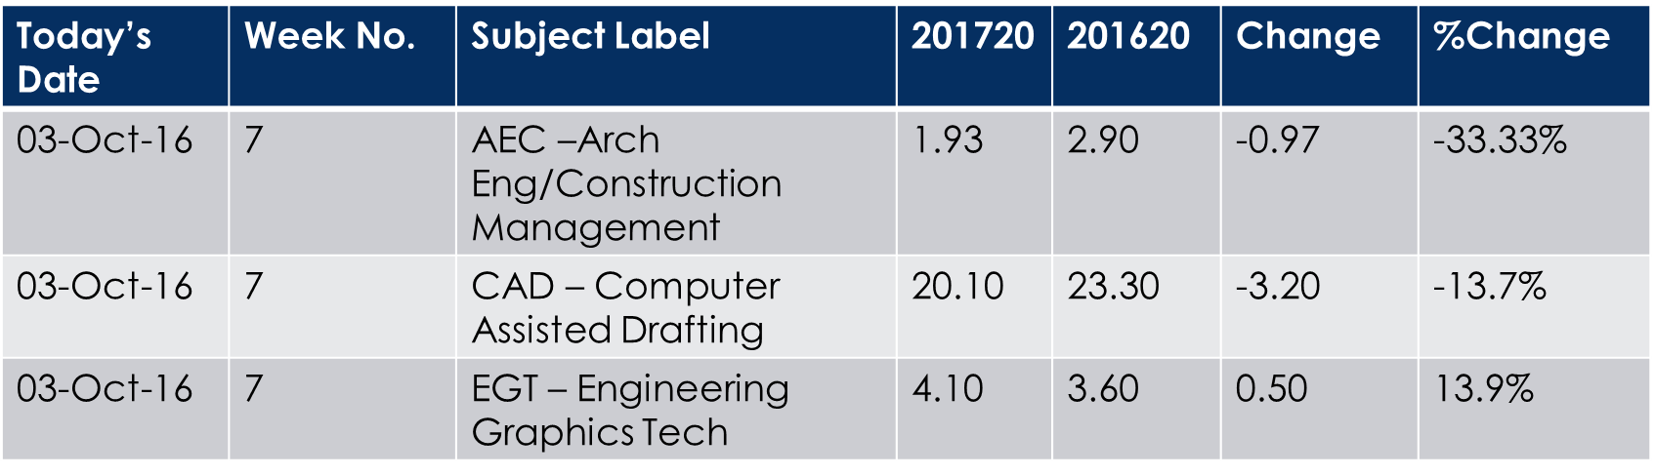
201720 FTE by Subject YTD Comparison
FTE comparison Oct2015 – oct2016

FTE COMPARISON
Conclusions and future action

- What conclusion can be drawn from the results? What action will be taken based on the results?

