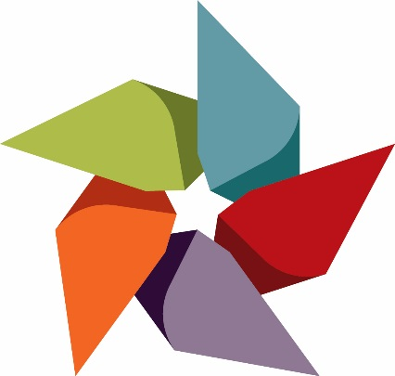

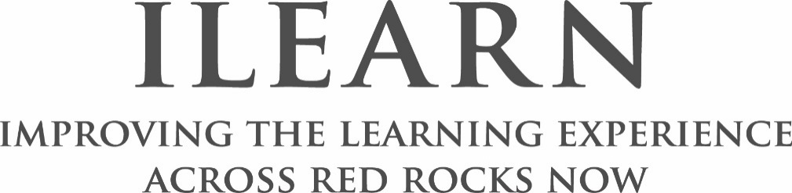

[Name of Operational Unit]
Continuous Improvement Plan
[Date}
Contributors
[Name]
[Name]

RRCC Mission
Our mission is to provide students with opportunities for growth and development that set the foundation for self-directed learning, academic achievement, and career accomplishment. We do this through high quality innovative educational programs that convey our passion for learning, our commitment to excellence, our dedication to our students, and the communities we serve.
RRCC Goals & Objectives
Goal 1 – Student Success
- Increase remedial completion
- Improve retention and completion rates
- Develop innovative academic programming
- Develop ongoing program review for all programs
- Expand innovative use of instructional technology
- Upgrade facilities to resolve space issues
- Improve advising and “smart scheduling”

Goal 2 – Community Engagement
- Increase access for underserved students
- Increase attainment for underserved students
- Lower student debt load and default rates
- Build programs and services that benefit community
- Build enrollment through community partnerships
- Build international education and global programs
- Higher education marketing in West Metro

Goal 3 – Institutional Renewal
- Digitize and share student information for advising
- Develop technological and facilities infrastructure
- New methods and platforms for instruction
- Increase diversity through hiring
- Develop health and wellness services and training
- Expand professional development opportunities
- Implement Process Improvement Team findings

Goal 4 – Culture of Inquiry & Evidence
- Develop Common Student Learning Outcomes
- Develop co-curricular learning goals
- Establish clear pathways to completion
- New instructional delivery centers and options
- Complete an Academic Master Plan
- Develop career planning and experiential education
- Develop systemic data collection and dissemination

Operational Unit Mission Statement

Operational Unit Goals & Objectives
Goal 1:

Goal 2:

Goal 3:

Goal 4:

Evidence & Supporting Documentation
[This section will require some narrative on your part; attempt to answer the following questions, using graphs and charts where appropriate]
- How did you go about determining your goals utilizing data?
- What data points, research, or best practices did you look at to determine your OU goals?
- What did the data tell you?
- Why did you decide on this specific quality improvement plan?
- What do you hope to accomplish?

Implementation Timeline
Spring 2018 | Summer 2018 | Fall 2018

Spring 2019 | Summer 2019 | Fall 2019

Spring 2020 | Summer 2020 | Fall 2020

Spring 2021 | Summer 2021 | Fall 2021

RESOURCES AND SUPPORT
Anticipated Challenges
[Include here any challenges you anticipate in reaching your goals and how you plan to address those challenges]
Resources
[This section is for a narrative of what resources (human, monetary, etc.) you would need to accomplish your goals.]
Use the chart below to outline any budgetary needs you foresee.
Budget
Item | Cost | How the resource supports the Operational Unit goals
Total Request Amount | $0.00

OU Goal | Objective/Outcome | Data used to Evaluate (the objective) | Benchmark/  Internal Target | Deadline/Date to Assess | Person Responsible
Goal 1: | 1a.
 | 1b.
 | 1c.
Goal 2: | 2a.
 | 2b.
 | 2c.
Goal 3: | 3a.
 | 3b.
 | 3c.

For more information, see the RRCC Strategic Plan: http://www.rrcc.edu/sites/default/files/strategic-planning-RRCCStrategicPlanFinal.pdf

