Compliance to Commitment, Changing the Narrative of Assessment

Important Tips About Assessment
- It is a tool to drive improvement and highlight progress
- Asking the right question leads to collecting the right data

Asking the Right Question
As educators, we are always thinking about how students learn and whether they are absorbing the material we deliver. Data can help us promote our strengths and grow from our weaknesses. In order to collect the data we are looking for, we have to ask the right question. To formulate the right question, think about a single topic or skill that students struggle within your curriculum.

Act (Teaching and Assessment)
- What teaching styles (e.g. lectures, group work, presentations, videos, etc) do I use to deliver the topic?
- What formative assessments (e.g. quizzes, homework, exit tickets, etc) do I design for the students to demonstrate that they are learning the topic?
- What summative assessments (e.g. tests, projects, presentations, etc) do I design for the students to demonstrate that they learned the topic?

Analyze (Revisit and Reflect)
- Do I have time to revisit the topic if the assessments reveal that the students haven’t fully grasped it?
  - What can I provide for self-study if there is not time in class?
- When the class/topic is over, what questions do I ask myself to improve my teaching?
- What am I looking for to confirm that students have learned the topic?

Adjust (Continuous Improvement)
- Should I change the way the topic was delivered?
- Should I change the way the assessment measures learning?
- Does this topic require further investigation?

Plan (Question Development)
- What knowledge or skills do I want my students to learn after completing this topic?
- What data do I want to collect about my students learning?
- Am I asking the right question in the assessment to gather that data

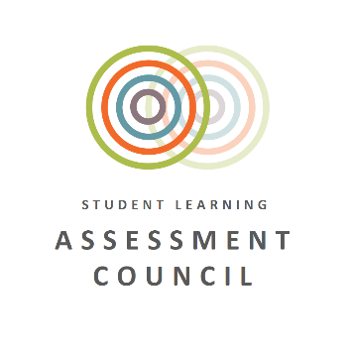

Assessment Council can help: collate and centralize ideas, discuss assessment types, design rubrics, generally talk about assessment

