April 25, 2024 ATP Meeting Minutes

- Our guest speakers today were from our new employee financial wellness benefit provider, My Secure Advantage (MSA)
  - Customer Success Account Manager, James Pointer and
  - VP, Partner and Client Success, Stacy Benner
James and Stacy are in the Central Time Zone, so the agenda went out of order a bit to make sure they weren’t staying at work too late. Stacy provided an overview of the services MSA provides. These are free to RRCC ATP employees. For those unsure of what 24/25 employee benefits to select, you might give MSA a call. (See attachment and video for details.)
  - Their digital platform (including the Wallet) is accessible all-year-round.

- We are excited to announce our new 24/25 ATP Chair-Elect, Lauren Brown!
Lauren has volunteer-partnered with Student Life and other RRCC departments to make so many of our events amazing. Last week, Lauren was in Phoenix, Arizona receiving the 2024 NIRSA Regional Award of Merit. NIRSA is a national collegiate recreation association with over 4,500 members. Right on, Lauren!

- Intros & Words of Gratitude
  - Jennifer Lammers thanked Evan Kravitz for the successful event on 4/24/24. (I should have added that Evan gave an awesome presentation at the Denver Scholarship Foundation meeting recently as well!)

- Individual experiences with our selected employee benefits…
  - Jordan shared that being on an HMO plan was very costly when his twins came into world.
  - Terri shared that having an FSA was a life-saver when she received over $800 worth of bills for some biopsies done at an outpatient surgery center.
    - Alerus Flexible Spending Account (FSA) - Around $600 can be carried over to the next plan year (July 1st – June 30th). List of eligible healthcare expenses = https://help.alerusrb.com/employees/health-savings-account/pre-tax-benefits-eligible-expenses/
  - Jennifer shared that she’s thankful for having health insurance. She’s saved about $164,000 on her surgeries.
  - I want to encourage folks to reach out to My Secure Advantage or other experts if they’re unsure of which benefits might be best for their particular situation.

- When is Open Enrollment?
  - The period for electing employee benefits for the next plan year is underway and ends 5/13/24. After that time, we are not eligible to amend our benefits coverage unless we experience a “qualifying life event”.
  - The 24/25 benefits will be valid July 1, 2024 – June 30, 2025.
  - 24/25 is a PASSIVE enrollment year, which I believe means that any previously enrolled coverages automatically carry forward except for FSA.
  - Even if you elect the same benefits, you may want to review your beneficiaries.
- What is TBX? The Benefits Experts – an English and Spanish, cloud-based employee health benefits enrollment platform (access in Employee tab of The Rock)
  - Provides custom videos to help you understand all your plan options and how they work. If you need help deciding which plan is best for you and your family, their decision support tool, Benefits Genius™, can help.
  - Click here to enroll in upcoming PERA Defined Benefits (DB) Plan webinars
  - Will any other new benefits be offered for 24/25?
    - Pet Insurance
    - LegalEase (similar to LegalShield, which he had prior) and
    - Medical flight insurance, aka medivac (i.e. helicopter transportation from a remote area or area with no hospital, for someone seriously injured

A tip from HR Benefits Specialist Michele McCall: “If you are in your last 4 years before retirement, you may want to change your deductions from pre- to post-tax in order to increase your highest average salary (HAS).”

- RRCC job vacancies/posted announcements – Angelee has been emailing us with posted job vacancies. If departments have a position that has not been posted just yet, but you would like us to keep an eye out for it, to share with our networks, speak now! *Evan mentioned that Marie Martin’s position will post soon.*

- The 2024-2028 RRCC Strategic Plan is posted online. This Plan helps us understand what drives every decision at RRCC. It is also useful for developing our Performance Plan goals.

  - Consider having one of your Perf Plan goals be to review and give feedback regarding Shared Governance, which might include attending some of the RRCC Collaboration Council meetings throughout the 24/25 year.

- Department updates
  - Lori Cook, our new Director of the in-the-works Associate Degree in Nursing (ADN) program, introduced herself. She is located near the PA program, in room 7136. Stop by and say hi to her! She’ll need more staff the closer RRCC gets to offering the program. Right now we’re in Phase I, so we can’t formally announce having the program. Phase II, which Lori expects to come sometime between October 2024 and January 2025, will allow us to announce the program to the public (after the State Board officially approves it). The first cohort offered, hopefully in Fall 2025, will total 30 students. Welcome, Lori!
  - The U.S. Department of Education has delayed the release of 24/25 FAFSA applications. We’re expecting to receive them sometime in May. We’ll need to do some behind-the-scenes programming and file clean-up before we can actually get students awarding, which we expect to begin in June.

- Upcoming 2024 Professional Development Opportunities
- National Association of Foreign Student Advisers (NAFSA) International Education Conference – May 28 - 31 in New Orleans, LA
- Career Education Colleges & Universities (CECU) – June 11 - 13 in Indianapolis, IN
- GlobaMindED Conference (10th Anniversary) – June 17 - 19 in Denver, CO
250+ Speakers on 90+ Topics, from Education to Health to STEAM to Policy
- International Society for Technology in Education (ISTE) – June 23-26 in Denver, CO
- The biennial National Association of Student Personnel Administrators (NASPA) Institute June 23 - 26, 2024 | Lewis & Clark College, Portland, Oregon
- eduWebSummit – July 9 - 11 in Philadelphia, PA
- United Negro College Fund (UNCF) UNITE Summit for Black Higher Education – July 28-Aug 1 in Atlanta, GA
- National Association for College Admission Counseling (NACAC) – Sept 26-28 in Los Angeles, CA
- Gardner Institute October 10 - 11, Pittsburgh, PA Take a deep dive into transformation for student success.
- Association for the Study of Higher Education (ASHE) Conference – Nov 7th (virtual) or
Nov 20 - 23 in Minneapolis, MN
- Online Learning Consortium (OLC) Summit – Nov 18 - 21 in Orlando, FL
- Free higher ed webinars - https://www.innovativeeducators.org/collections/free-training-higher-education-professionals

- From Terri Cedillo: Thank you all for making 23/24 a memorable and successful year. As outgoing ATP Chair, I can say that I have learned and grown a lot from this role. I am so excited for our 24/25 Chair, Jennifer Lammers, and 24/25 Chair-Elect, Lauren Brown, to continue building upon the unique contributions that each ATP Chair has made to the ATP Council and the College over the years. I know they’ll be awesome!

These screenshots may be helpful. Also, skim through the Benefits Guide Michele McCall emailed us before electing your 24/25 Plan options. An explanation of the options can be found there!
For a quick cost comparison, the Rates Chart Michele sent in the same email is also helpful.

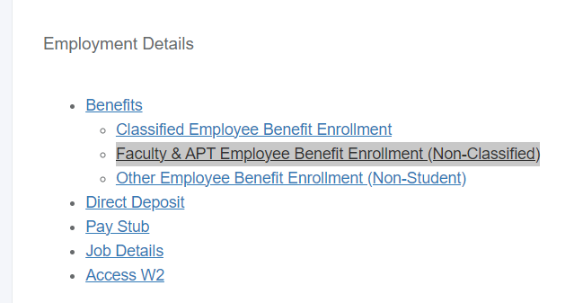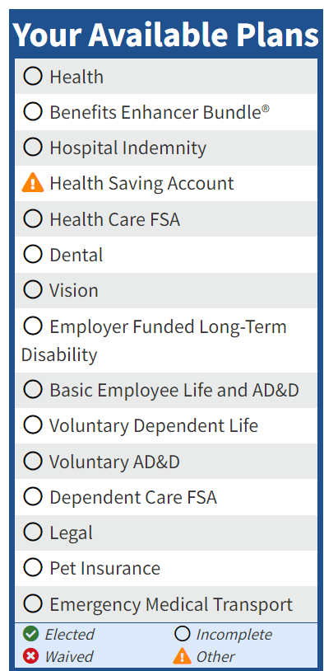

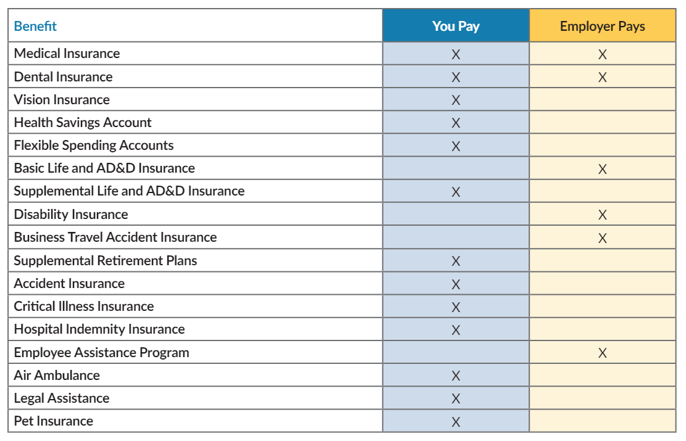

According to USAToday – Best health insurance companies of 2024:
- Kaiser Permanente: Best health insurance.
- Aetna: Best health insurance for young adults.
- Blue Cross Blue Shield: Best health insurance for the self-employed.
- UnitedHealthcare: Best health insurance provider network.

I was happy to see our two health providers on the list! TLC

RRCC job announcements can be found at https://www.schooljobs.com/careers/rrcc?
Here is the latest email from HR as well:
